Abhishek Verma
Mobile No. +91 98861 78820
E-mail : alcverma@hotmail.com CURRICULUM VITAE

CAREER OBJECTIVE
Thriving to quench the thirst of inventing solutions that transcend device boundaries, by leveraging the skills developed through experience. To consummate the desire for undertaking challenging tasks, and managing teams by being an integral part of a Global IT Solutions Provider in the dynamic industry driven by Information Technology.

PROFESSIONAL SUMMARY
- Associate Test Manager with over 2 years of test management experience. Total IT experience of close to 9 years.
- 6.5 years of experience in software testing in telecom domain.
- Proven ability to establish and direct effective QA programs.
- Highly knowledgeable in Computer Engineering and Product Testing.
- Familiar with Windows, Linux and UNIX environments.
- Adept at Regression Testing, Black box testing, Functional Testing, Performance and Stability Testing.
- Able to develop Test Procedures and Standards, prepare documentation and oversee all aspects of Software development.
- Managing the testing team with Technical Assistance.
- Decision Taking with respect to Release Dates, Resource Allocation etc.
- Preparation of Reports for the Organizational Analysis of the Team’s performance.
- Analysis of Change Requests from Customer.
- Excellent leadership, presentation and communication skills.

CAREER PROFILE
- Working with Subex Ltd Bangalore as Associate Test Manager from 1st April 2012 till date, worked as Senior Engineer-Testing & Configuration from 12th November 2008 till 31st March 2012.
- Worked with Logica Pvt Ltd Bangalore as IT Consultant from 27th October 2005 till 10th November 2008.

TECHNICAL SKILLS
Operating Systems : UNIX/Linux, Windows 2000/XP/Windows 7, HP-UX, Solaris, IBM-AIX
Test Management : Test Link, SDP, Test Director, Clear Quest Web, Bugzilla
Configuration Management : SVN, CVS
Databases : Oracle9i/10g/11g
Scripting Languages/Automation : shUnit (Shell scripting), WATIR (Ruby)
Other Tools : Diamond/Spark

ACHIEVEMENTS & CERTIFICATIONS
Subex Ltd:
- UAT, Integration and Production Launch of CR3342: Number Dial Migration ROCFM V7.0 for 3 weeks at Mobinil, Egypt
- Did data gathering for site implementation of ROC FM V7.4.2 for Orange Conakry, Guinea 
- Rewarded thrice with ‘Hats off’, twice for successfully testing and delivering Vodafone Essar Limited and Aircel 3G releases for FMS on time, and once for commitment and critical release deliveries to Swisscom Switzerland
- Rewarded with 'Pat on the back' for the best support delivered, Issues resolved and timely service of requirements designed for all clients in ROCFM Support team.

Logica Pvt Ltd:
- CTFL (Certified Tester Foundation Level) in ISTQB 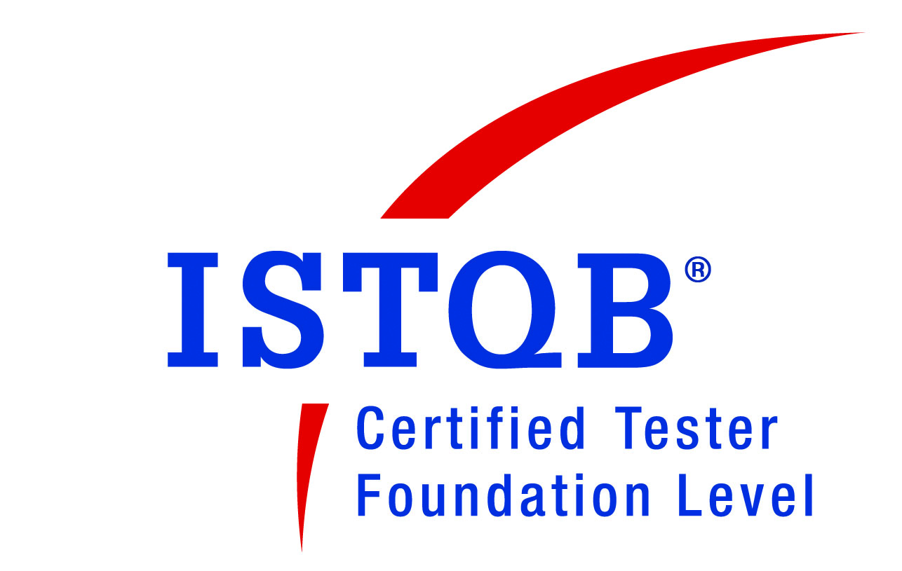on 24th April 2008.

PROJECT DETAILS
Project Name : ROC Support-Fraud Management System [FMS]
Organization : Subex Ltd, Bangalore
Versions : V5.1 to 5.4/6.1 to 6.2/7.0 to 7.4.2/8.x
Operating Systems: Windows XP, Linux, Solaris, AIX and HP-UX
Duration : November 2008-Till Date
Roles : Associate Test Manager/Senior Engineer Testing & Configuration
Client : APAC: Idea, Vodafone, Tata Teleservices, Aircel, Airtel, DTAC-Thailand,
Celcom & Telekom Malaysia etc
EMEA: Geocell Georgia, Azercell Azerbaijan, Moldcell Moldova, Telekom Slovenije, Qtel Qatar, STC Saudi, MTN Iran, Polkomtel Poland etc
Americas: Rogers Canada, CNT Ecuador, Telefonica Chile etc
Technologies : Java, C++, Ruby, Linux Shell Scripting
Tools : Bugzilla, Diamond

Project Overview: ROC Fraud Management System, a Subex ROC component, helps in detecting frauds by highlighting usage patterns and matching subscriber profiles against known fraudsters. ROC FM monitors the Subscriber’s calling patterns based on predefined rules and generates Alarms / indications whenever a deviation is observed in “normal” calling pattern of subscribers.

Some of the Modules of the product:
Rule Management: eFingerprint rules, Statistical rules, AI rules, Smart Pattern rules
RATE (Ranger Auto Threshold Engine), Hot List Management, Alarm Management, Subscriber Auto Grouping, Subscriber pre-check, IAQ (Intelligent Alarm Qualifier).

Responsibilities (As Associate Test Manager – from June’12):
- Managing support test team.
- Creating test plan, preparing release plan, providing release dates and preparing resource utilization matrix. Following up any outstanding open test risks/issues, attending escalation meetings. Preparation of Reports that include Monthly Bug Statistics Report, Resource Utilization, Effort Variance & Schedule Variance Report, Release Status Report of the Team.
- Reviewing change requests (CRs) and providing effort estimates (testing scope/duration) for CRs to be tested by team.
- Attending CR review meets with project leads to draw outline for CRs to be tested by team, reviewing test scenarios/release documents prepared by team to make sure quality is not compromised with. Helping them in automating the test procedures.
- Driving with team to complete bug-free and on-time project deliveries, helping them in technical and procedural aspects.
- Mentoring & guiding the team members, working closely with them to identify areas of improvements, and training needs if any, arranging for the same.
- Evaluating team members’ performance and appraisals.
- Reviewing of requirement documents and technical specifications.
- Sync up discussions / calls with the North American Customer Support Team.
- Preparing data gathering questionnaire (DGQ), business requirement document (BRD), and functional specification (FS) for ROCFMS implementation for new customers.
Responsibilities (As Senior Engineer Testing & Configuration – till June’12):
- Bringing test setups, including customized ones.
- Test case designing for functional, system and regression testing.
- Execution of test cases and bug reporting in Bugzilla.
- Adding user stories and corresponding tasks in Mantra to follow agile process.
- Testing the build compatibility across various operating systems.
- Change request analysis from testing perspective.
- Providing technical guidance to other team members.
- Constantly working with developers to get the bugs reproduced and resolved.
- Carrying out performance testing and automation testing using shUnit as scripting language.
- Development activity: Designing the data sources, for processing different format data as ASN1, ASCII and binary.

Project Name : Unified Open Network Exchange (uOne)
Organization : Logica Pvt Ltd, Bangalore
Duration : March 2006-March 2008
Role : Software Test Engineer
Client : Belgacom & Proximus Belgium, Telecom Italia Italy, Videotron Canada etc
Technologies : LDAP, IMAP, Linux.
Tools : Mercury QC 8.2, Clear quest

Project Overview: These full voicemail applications had many features like Notification Management, Greeting Management, Security Features (PIN), Missed Call Notification, Outdial Notification, Legacy Outdial etc. These were deployed at Belgacom Belgium & Proximus Belgium, telecom giants in Belgium.

Responsibilities (As Software Test Engineer):
- Reviewing of SRS and SDD.
- Writing of test cases for various Features in Mercury Quality Center.
- Validation of test cases written by fellow testers.
- Execution of test cases.
- Involved in System testing (Functional Testing).
- Updating issues in bug reporting tool CQWeb.
- Retesting fixed bugs & regression testing.

ACADAMIC DETAILS
- B.E (Computer Science & Engineering) from MPCCE&T, Bhilai (CG) in 2004 with 72.3%.
- HSC from MP Board, Bhopal (MP) in 2000 with 72.4%.
- SSLC from MP Board, Bhopal (MP) in 1998 with 76.2%.

PERSONAL DETAILS
Date of Birth : 04/03/1983
Sex : Male
Marital status : Married
Nationality : Indian
Passport number : J4662157 (Valid till 02-02-2021)
Languages known : English, Hindi
Address : #128, Elegance Garnet, Near Bellandur Junction, Sarjapur Outer Ring Road
Bangalore-560103

(Abhishek Verma)

